**Instruction of AiR NFT Factory Installation**

**(Ubuntu)**

1. **how to install environments of node & npm & yarn, github, mongoDB, mongo compass(or mongo chef), phantom wallet(or other wallets) and solana tool suite.**

* **node & npm**

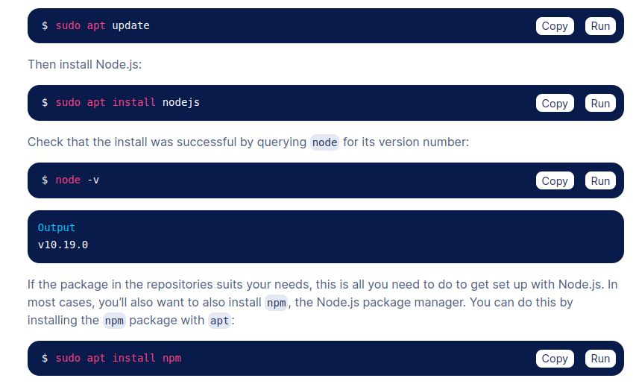

Refer link:

<https://linuxhint.com/install-node-js-npm-ubuntu-s20-04/>

<https://www.digitalocean.com/community/tutorials/how-to-install-node-js-on-ubuntu-20-04>

<https://linuxize.com/post/how-to-install-node-js-on-ubuntu-20-04/>

* **yarn**

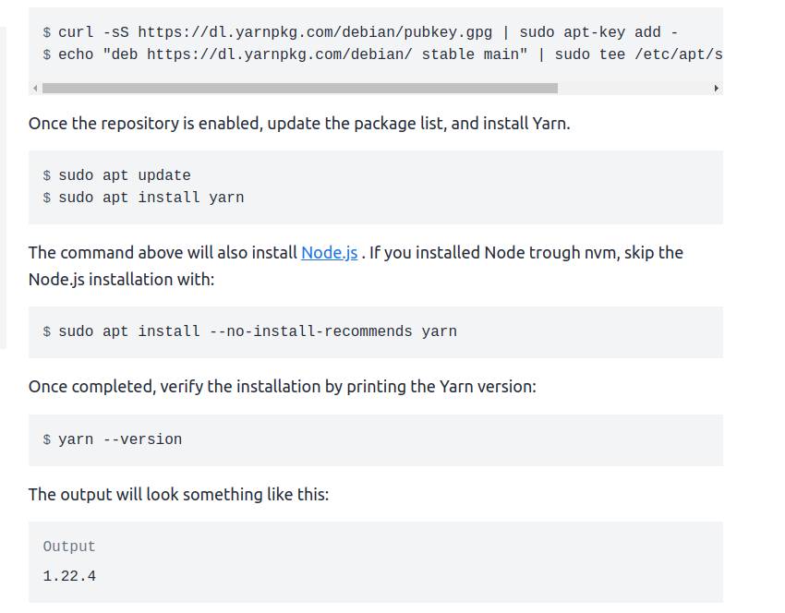

refer link:

<https://linuxize.com/post/how-to-install-yarn-on-ubuntu-20-04/>

https://linuxhint.com/install_yarn_ubuntu/

* **github**

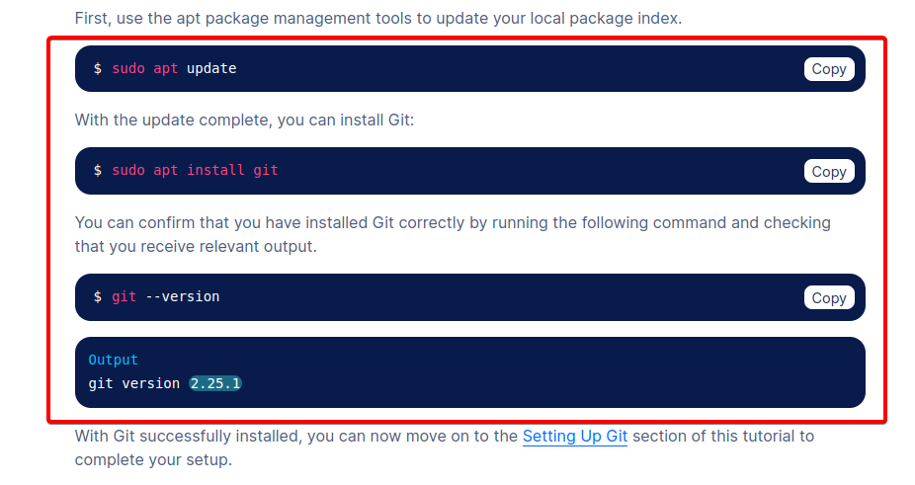

Refer link:

<https://www.digitalocean.com/community/tutorials/how-to-install-git-on-ubuntu-20-04>

<https://github.com/git-guides/install-git>

* **mongoDB**

sudo apt update

sudo apt upgrade

sudo apt install mongodb

sudo systemctl status mongodb

sudo systemctl start mongodb

sudo systemctl enable mongodb

refer link:

<https://linuxhint.com/install_mongodb_ubuntu_20_04/>

<https://www.cherryservers.com/blog/how-to-install-and-start-using-mongodb-on-ubuntu-20-04>

<https://www.digitalocean.com/community/tutorials/how-to-install-mongodb-on-ubuntu-20-04>

* **mongo compass (or you can install mongo chef to manage mongoDB with gui)**

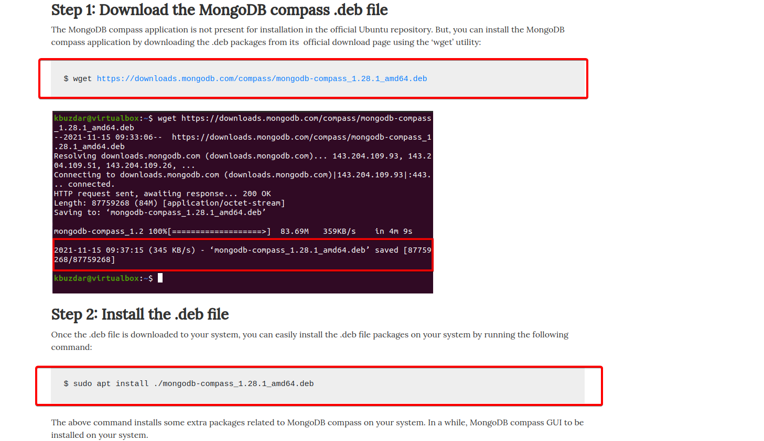

Refer link:

<https://linuxways.net/ubuntu/how-to-install-mongodb-compass-in-ubuntu-20-04/>

<https://www.how2shout.com/linux/install-mongodb-compass-gui-in-ubuntu-20-04-lts-linux/>

* **phantom wallet**

Refer link:

https://phantom.app/download

<https://chrome.google.com/webstore/detail/phantom/bfnaelmomeimhlpmgjnjophhpkkoljpa>

* **Solana Tool Suite (no need to install for users, it’s only for devs!)**

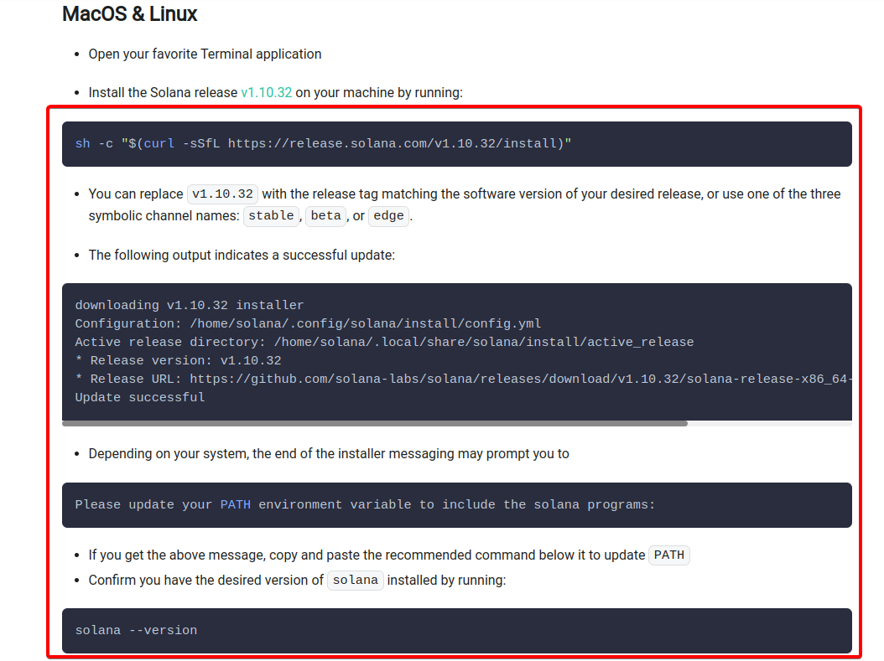

Refer link:

<https://docs.solana.com/cli/install-solana-cli-tools>

1. **After install all environments, clone the project(AiR-NFT-Factory) from github repository and then install node modules.**

* **Clone the project.**
* open terminal
* run this command:

git clone <https://github.com/airworld-io/AiR-NFT-Factory.git>

* **Install node modules**

after clone the project, run these command:

cd AiR-NFT-Factory/

yarn install

cd ..

cd api/

yarn install

cd cli/

yarn install

npm install -g typescript

npm install -g ts-node

1. **After install node_modules, create mongoDB and prepare solana wallet.**

* **Connect with mongo compass(or mongo chef) to manage mongo database and then create database called “air_nft_factory”.**

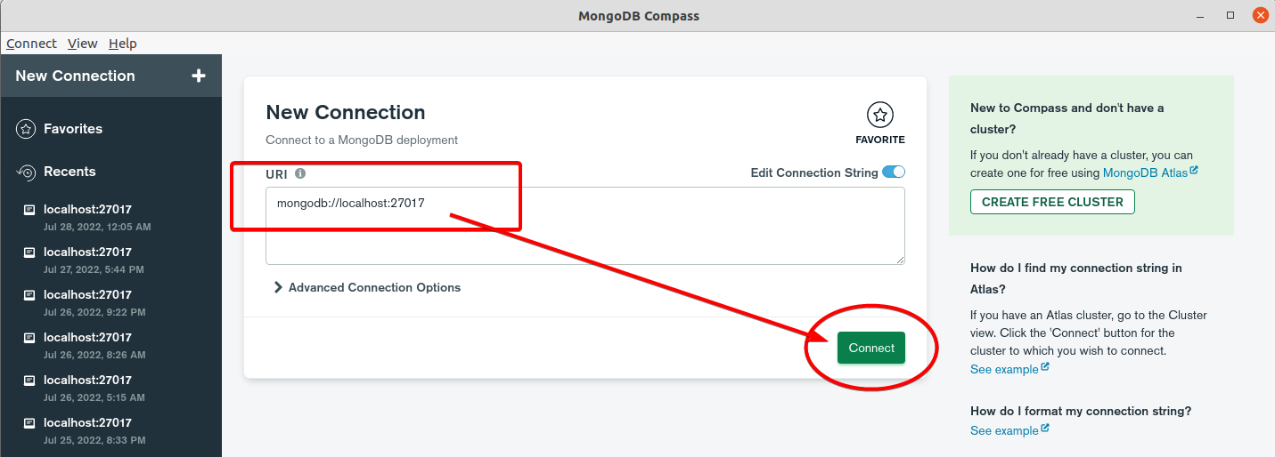

After connect with mongoDB compass, create database called “air_nft_factory” and collection called “users” like below image.

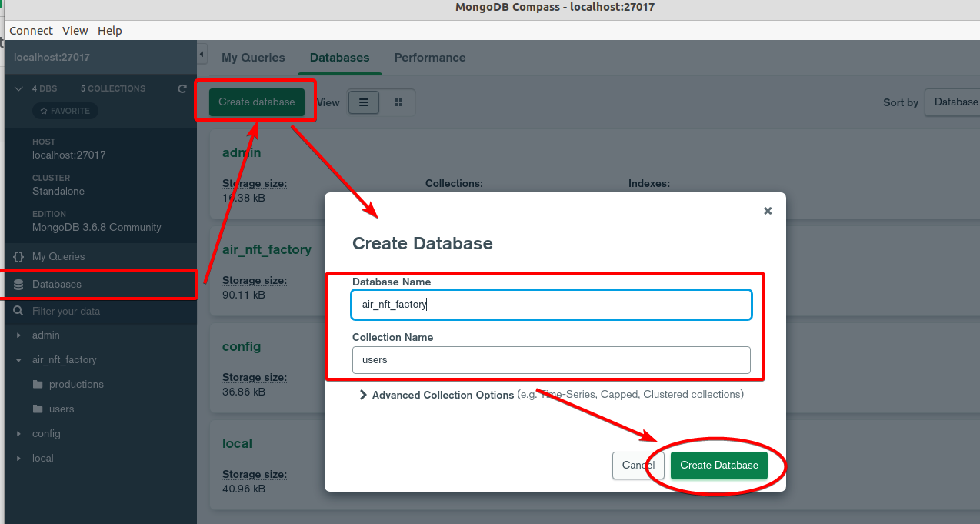

* **Prepare solana wallet**
* if you have devnet.json of solana wallet, no need to create one. Only need to copy and paste it to ~/.config/solana/devnet.json
* if you don’t have devnet.json of solana wallet, here are two ways to create it.

1. You can use solana tool suite to create it.

The content of devnet.json is same as solana wallet private key.

Thus, you can import and use it in any solana wallets such as phantom and etc.

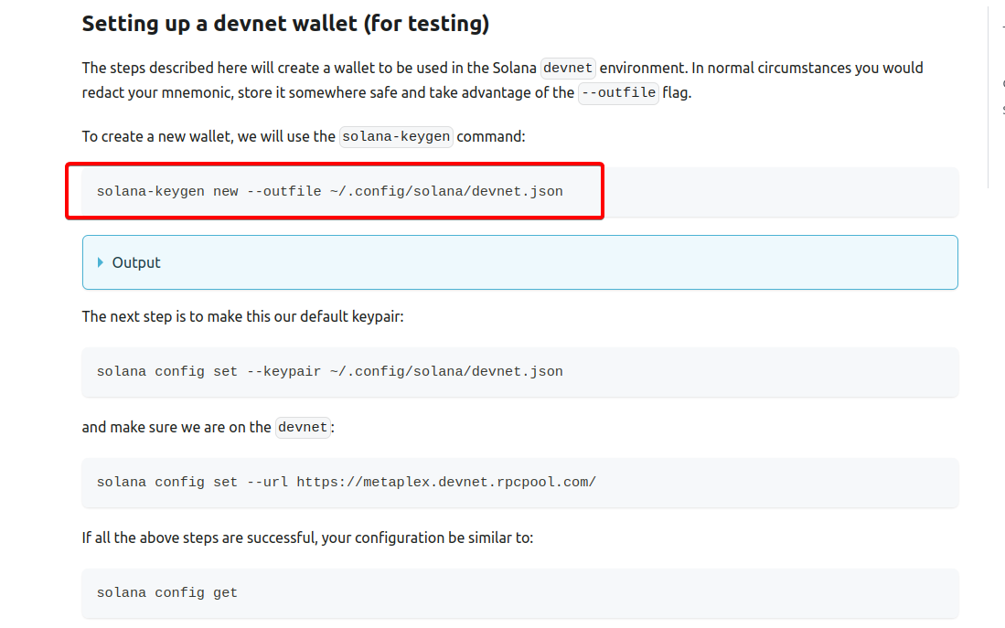

1. You can create it using solana tool suite with your seed phrase of the existing wallet(like phantom or etc).

Type this command:

solana-keygen recover 'prompt:?key=0/0' --outfile ~/.config/solana/devnet.json

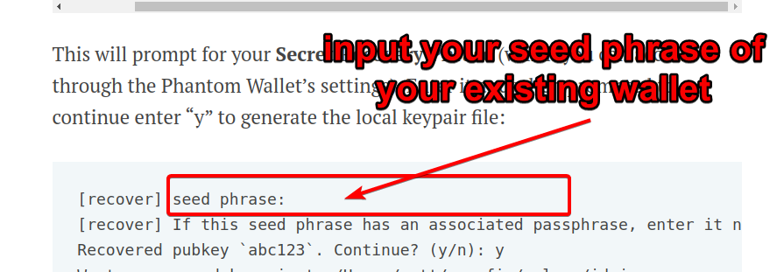

1. **Run the project.**

* You can use this command to run both server and client.

yarn dev

* Alternatively, you can open two terminals and then run the server and client independently in each terminal.

yarn server

yarn client